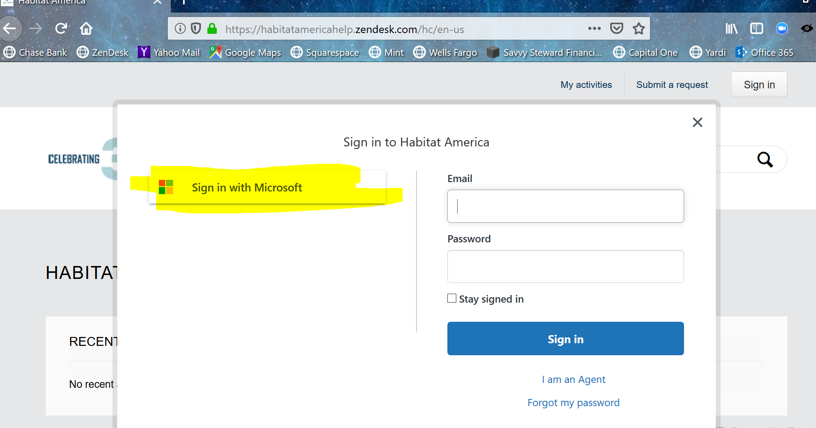
How to Sign In to the ZenDesk Help Center

1. Click on Sign in with Microsoft.

2. It takes you to the Office 365 sign in page. Sign in with your Habitat email and password.

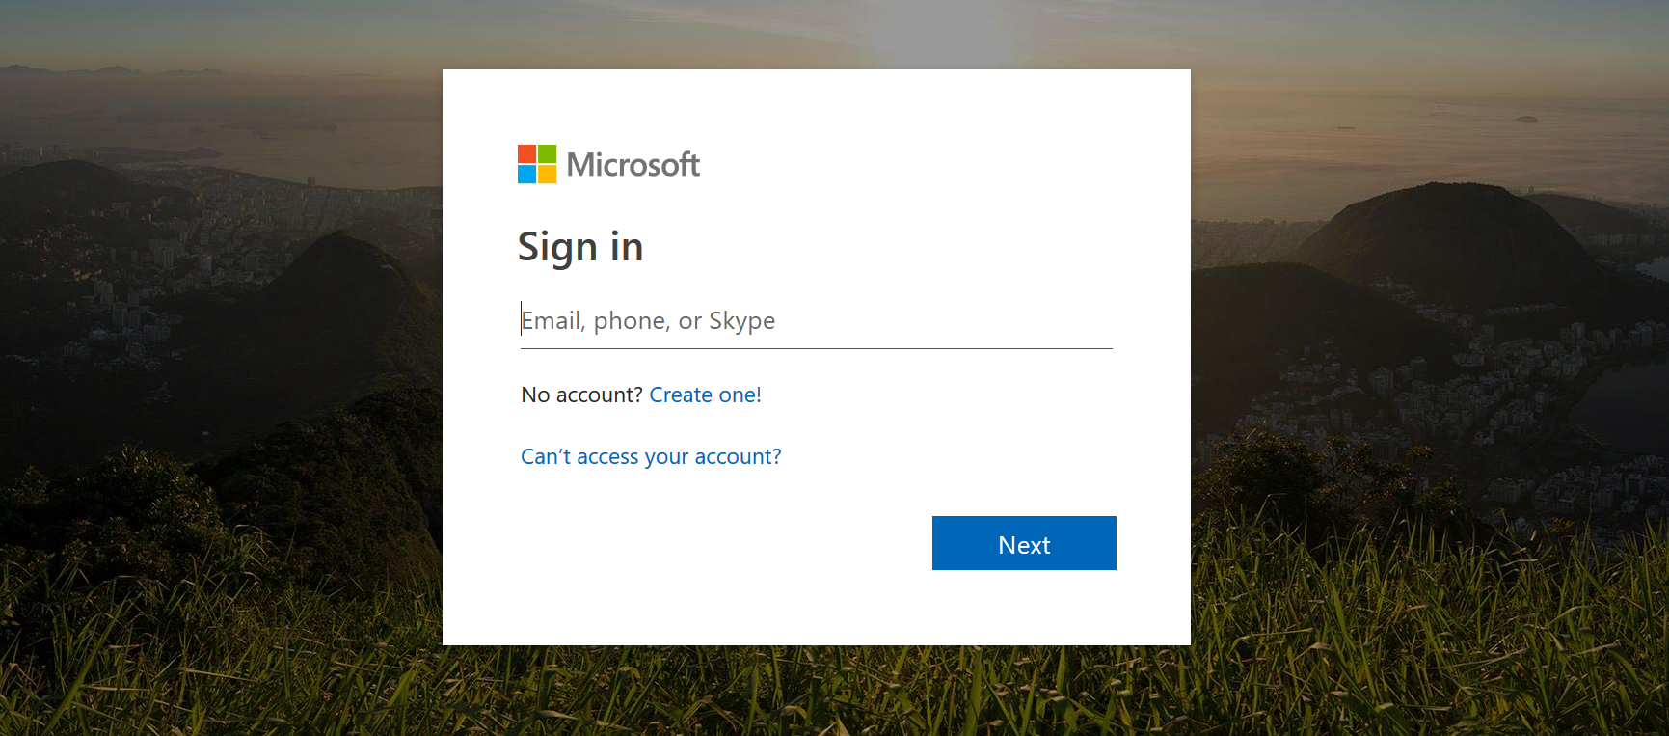
3. If you don’t know your email password, please click Submit a Request to send a tech support ticket.



